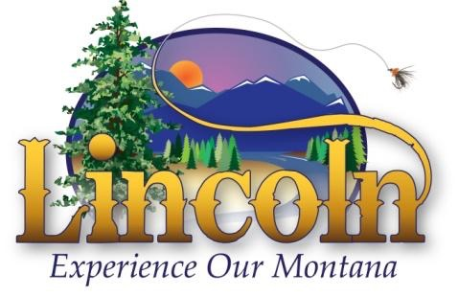
LINCOLN VALLEY CHAMBER OF COMMERCE
PO Box 985
Lincoln, MT 59639
Tel- (406) 362-4949
E-Mail- experiencelincolnmt@yahoo.com Web- www.lincolnmontana.com

2024 Membership
It’s membership time! Your membership dues will help the Chamber maintain our new website and develop e-commerce capabilities, continue the tradition of our July 4th festivities, and allow for the necessary insurance covering Chamber Officers/Board, and our annual parade.

The LVCC is an active partner in economic development efforts and supports numerous community activities.

THANK YOU FOR SUPPORTING YOUR COMMUNITY!

If you are a current member we are asking that you take a moment to:
- Review your membership profile and make any necessary changes via email to experiencelincolnmt@yahoo.com
- Submit your annual dues payment by February 28, 2023. Send payment to the LVCC P.O. Box 985
Lincoln, MT 59639
Membership runs from January-December

If you are joining as a new member, please note the available membership levels and advertising options, then:
- Choose your support level
- Fill out the attached membership profile and return via email or send with payment to the LVCC P.O. Box 985, Lincoln MT, 59639.

Membership Levels
· Commercial Business Membership $100
o Includes voting rights, your business listed on the Chamber website, and a bold listing in the Business Directory.
· Non-profit Membership $50
o Includes voting rights, your business listed on the Chamber website, and a bold listing in the Business Directory. You must have a valid non-profit ID# for this membership level.

Make checks payable to LVCC, PO Box 985, Lincoln, Mt. 59639
Chamber meetings are held quarterly at 5:30 p.m. on the 2nd Thursday of January, April, July, and October. Please consider joining us to help chart the path for Lincoln’s businesses.

